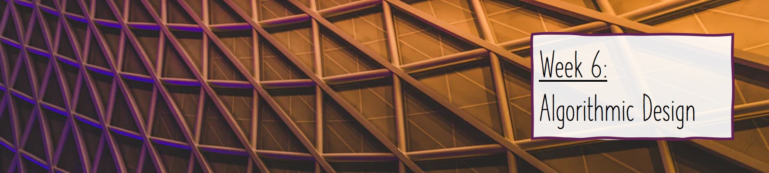

6.3: Algorithmic Complexity Crib Sheet

Finish the following sentences (the ________ indicates where you need to put your answer, in some cases, this represents more than just one word):

1. Algorithmic complexity is ________
2. We define complexity as function T(n) which is ________ vs ________
3. The complexity is used to ________
4. Algorithms will take different amounts of time with the same inputs depending on:
   1. ________
   2. ________
   3. ________
5. To overcome this issue, we measure T(n) as the number of ________
6. It is assumed that each step considered in algorithmic complexity takes a ________ time
7. Algorithmic complexity is useful for ________ and ________
8. ________ notation is used to represent algorithmic complexity
9. Worst-case runtime complexity is ________
10. Best-case runtime complexity is ________
11. Average-case complexity is ________

Complete the following table to have a record of the different types of algorithmic complexity:

| **Complexity** | **Notation**  ***(see answer to 8 above)*** | **Description** | **Example Algorithm**  ***(provide an example algorithm which has the complexity listed on each row)*** |
| --- | --- | --- | --- |
| Constant |  |  |  |
| Linear |  |  |  |
| Quadratic |  |  |  |
| Logarithmic |  |  |  |